Working Smart: Cross-Team Collaboration and Long-Term Projects in Jira

1. Managing Cross-Team Work in Jira
In large or long-term projects, work is often distributed across multiple teams (development, testing, UI/UX, DevOps). Jira supports cross-team collaboration by providing shared visibility, issue linking, and standardized workflows.
Key Challenges in Cross-Team Work
- Dependency management
- Visibility across teams
- Coordination of timelines
- Avoiding duplicate work

How Jira Supports Cross-Team Work
- Shared projects and issues
- Issue linking (blocks, depends on)
- Common labels and components
- Unified workflows
- Shared dashboards and reports

Hands-On Lab: Manage Cross-Team Issues
- Create an issue in Project A
- Assign:
  - Component: Frontend
  - Label: cross_team
- Link issue to Project B issue using:
  - Blocks / Is blocked by
- Track dependency across teams
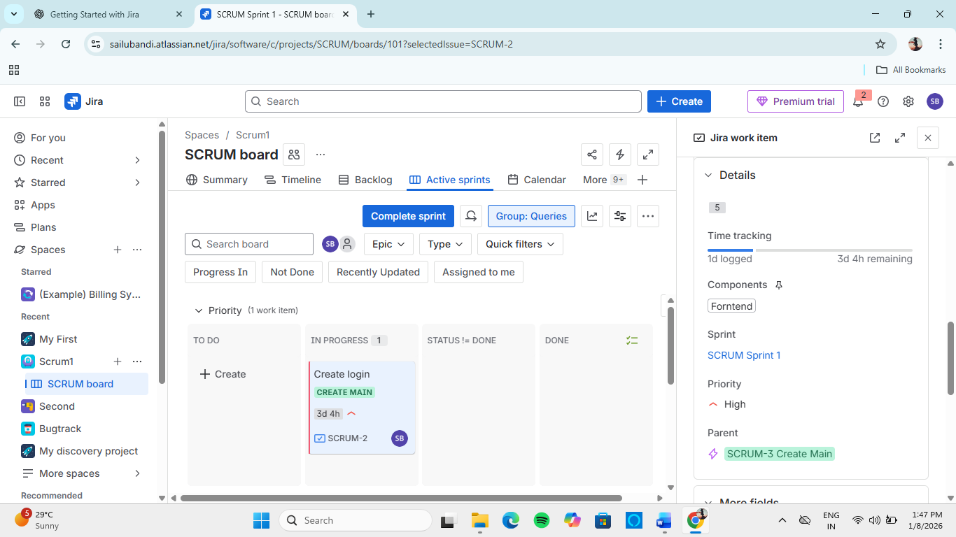
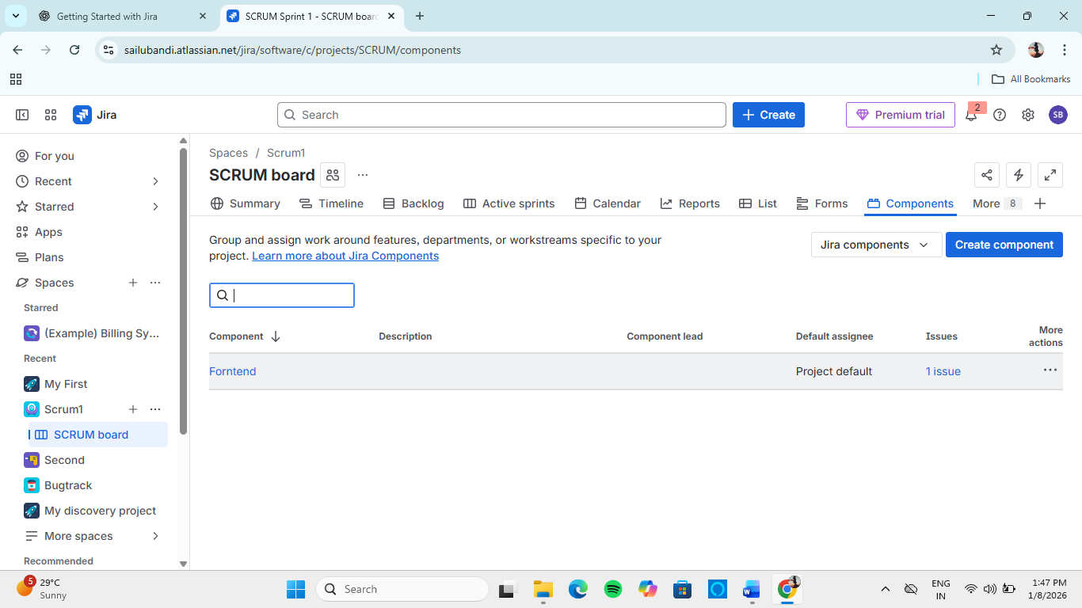

Best Practice
Use clear labels + issue links to identify cross-team dependencies early.

2. Creating and Using Shared Boards for Team Collaboration
A Shared Board allows multiple teams to view and manage issues together, even if they belong to different projects.

Why Shared Boards Are Important
- One common view for all teams
- Eliminates silos
- Improves transparency
- Supports coordination meetings

Types of Shared Boards
- Scrum Shared Board – Sprint-based coordination
- Kanban Shared Board – Continuous flow across teams

Hands-On Lab: Create a Shared Board
- Go to Boards → Create Board
- Select:
  - Scrum or Kanban
- Choose Board from an existing project
- Select filter:
  - Example JQL:
project in (PROJ1, PROJ2) AND status != Done
- Name board: Cross-Team Collaboration Board
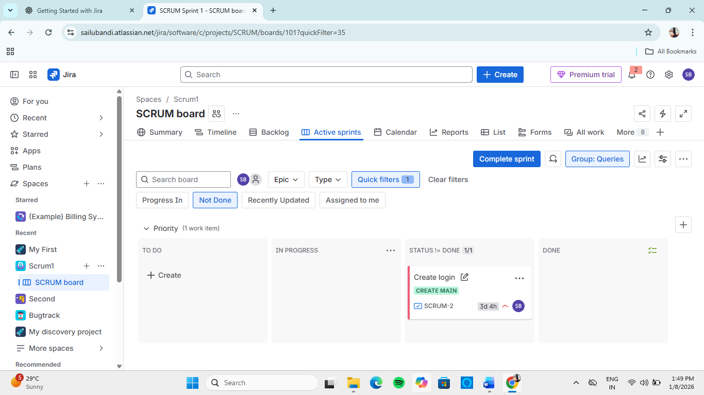

Using Shared Boards Effectively
✔ Use common workflow statuses
✔ Agree on definition of Done
✔ Use swimlanes by team or component
✔ Use quick filters for teams

3. Roadmaps in Jira: Visualizing Plans and Dependencies
A Roadmap provides a high-level, timeline-based view of work across teams and projects.
Roadmaps are especially useful for:
- Long-term planning
- Dependency visualization
- Stakeholder communication

What Roadmaps Show
- Epics and timelines
- Start and end dates
- Dependencies between issues
- Progress tracking

Types of Roadmaps
- Project Roadmap – Single project view
- Advanced Roadmaps – Multi-project, multi-team planning

Hands-On Lab: Create a Roadmap
- Open your Scrum Project
- Click Roadmap
- Add epics
- Set:
  - Start date
  - End date
- Drag epics to adjust timeline
- Link epics to show dependencies
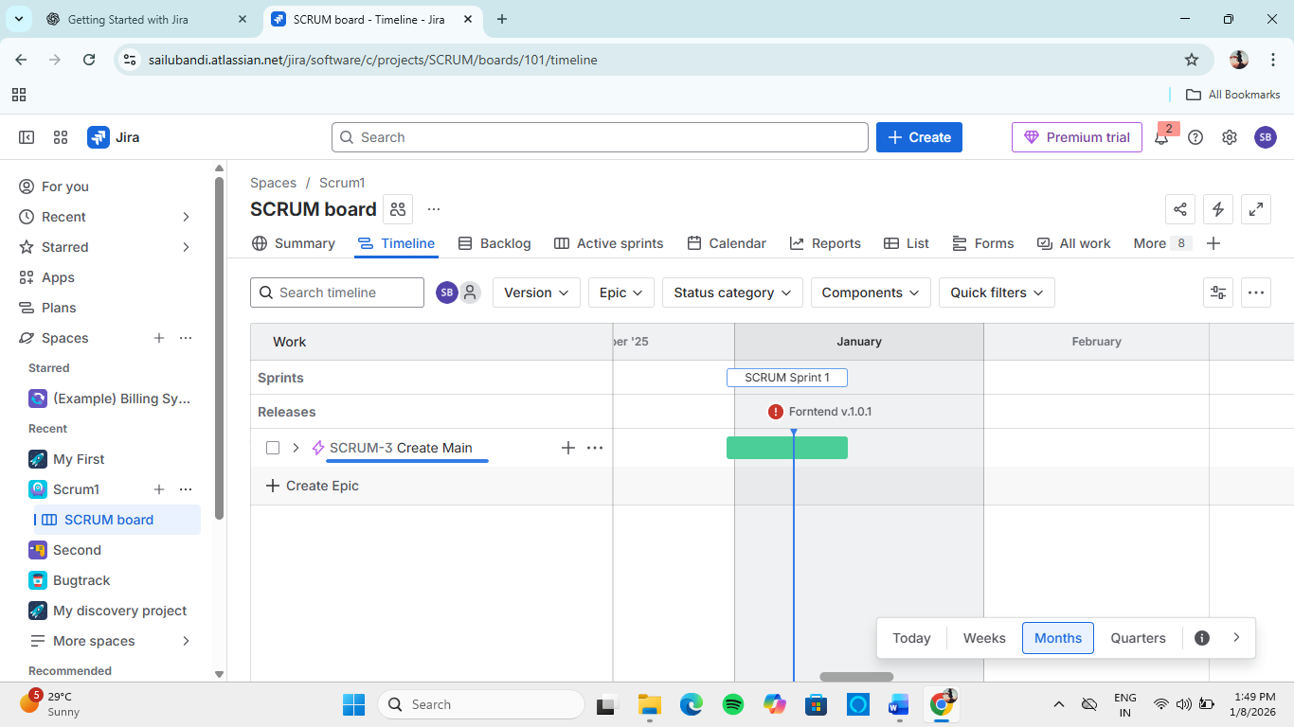

Understanding Dependencies
- Blocked by – Cannot start until another issue is completed
- Depends on – Sequential work
Roadmaps visually display these dependencies using connecting lines.

4. Best Practices for Long-Term and Cross-Team Projects
✔ Use shared boards for alignment
✔ Track dependencies using issue linking
✔ Plan work at epic level
✔ Keep roadmaps updated regularly
✔ Communicate changes through Jira comments

5. Learning Outcomes
After completing this module, the learner can:
- Manage work across multiple teams in Jira
- Create and use shared boards for collaboration
- Track dependencies between teams
- Visualize long-term plans using Jira Roadmaps

